Pulse Width Modulated Inverters

In a pulse width modulated inverter the desired sine-wave output (the modulation) is modulated onto a high frequency square wave. This can be done using a high speed digital signal processor but the traditional approach using a comparator to perform the modulation is perhaps easier to understand.

+
-
Modulation (V_{control})
Carrier (V_{tri})
Pulse Width Modulated Output

The amplitude modulation index is defined as: 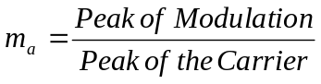. This will typically be less than one. An amplitude modulation index of more than 1 is possible but this leads to distortion of the output sine wave and in the extreme leads to a square wave output.

The frequency modulation index is defined as 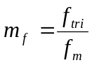where f_{tri} is the carrier frequency and f_{m} is the modulation frequency. We will be using a low pass filter to remove the carrier frequency and preserve the modulation frequency so the higher m_{f} the better. A minimum value of 9 is recommended. and values of between 100 and 1000 are fairly common.

The resulting pulse width modulated square wave is used to control the gates of the bridge inverter. The output voltage is a square wave at the carrier frequency but the width of the output pulses is modulated by the sine wave modulation. If we put a low pass filter on this output then the carrier will be removed and the resulting filtered output will be an amplified version of the modulation.
PWM Amplifier Output with Bipolar Voltage Switching
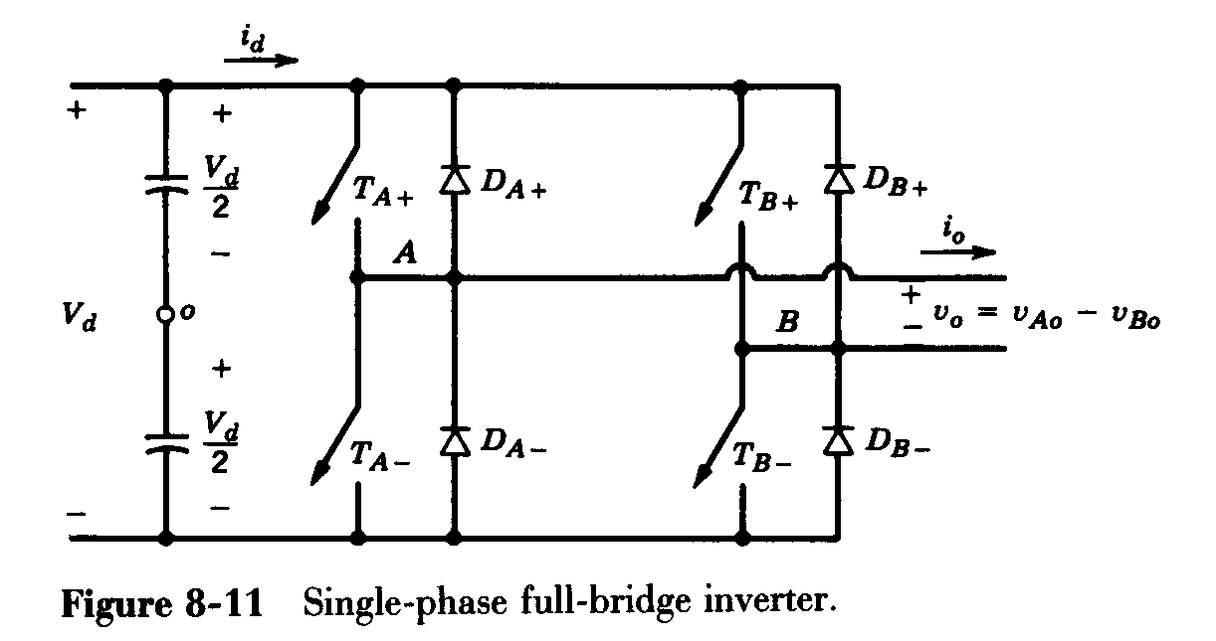
With bipolar voltage switching TA+ and TB- are switched on together when the PWM signal is high and TA- and TB+ are switched on when the PWM signal is low. That gives a square wave at v_{o} switching between +V_{d} to -V_{d}.

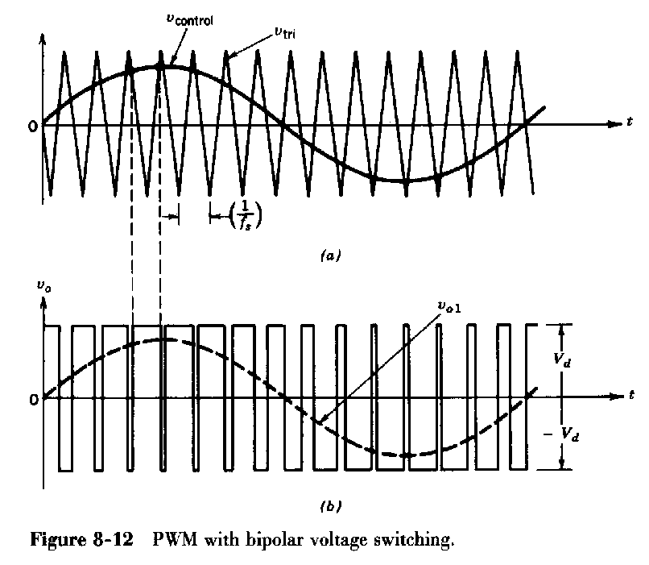
Figures on this page from Mohan Undeland and Robbins: Power Electronics
Fourier Analysis
A Fourier Analysis of the output square wave reveals that the output has a fundamental at the modulating frequency and harmonics centred around the carrier frequency.

f_{m}
f_{tri}
2*f_{tri}
Frequency
Voltageee
Fourier Analysis of the Pulse width Modulated Output

The Raw unfiltered pwm output is clearly not very sinusoidal. There are very large harmonics centred around the carrier frequency and its multiples.

Table below from Mohan Undeland and Robbins: Power Electronics
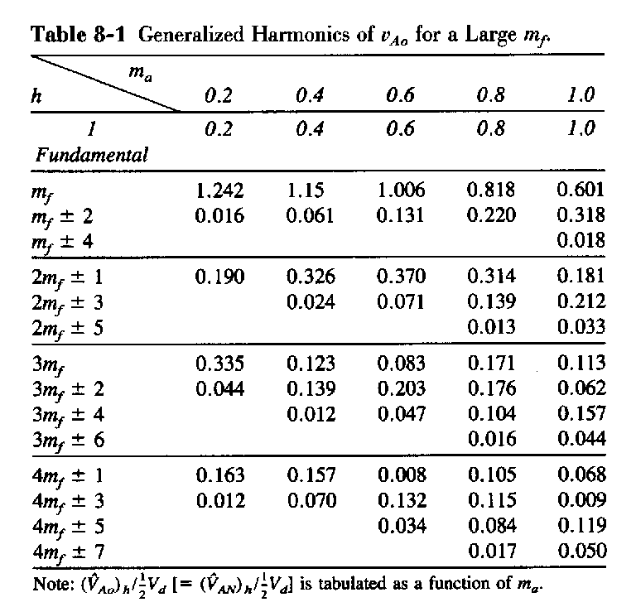
Extracting the underlying sinewave

If we use a low pass filter to remove the harmonics (easy to do if m_{f} is large) then the remaining output is a good sine wave with very low harmonic distortion. Some ripple will remain at the carrier frequency.

In practise a filter may not even be required because many loads (for example motors) have inherent low pass response characteristics.

Another view: The PWM amplifier.

If m_{f} is large then the modulating signal changes very little from one pulse of the carrier to the next. Therefore if we zoom in time the output will have a fairly constant duty cycle for several cycles.

+V_{d}
v_{o}
Average

-V_{d}

When v_{control} is above v_{tri} the output is +Vd. When v_{control} is below v_{tri} the output is –Vd.
The average output voltage (for this small increment of time) can be seen to be: 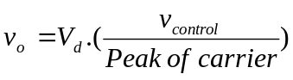

What we have actually constructed is an amplifier whose average output voltage equals the input voltage (v_{control}) multiplied by a gain of 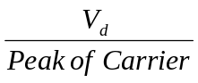. Therefore if we want to get a sine wave out we must put in a sine wave and the output will be equal to this sine wave multiplied by the gain. All of this assumes that the modulation sine wave does not exceed the peak of the triangle wave (m_{a} < 1).
Synchronous versus Unsynchronous Modulation

In our calculations we have assumed that m_{f} is an integer and that the modulation is in phase with the carrier. This is known as synchronous pwm. Synchronous pwm has the advantage that there are no low frequency harmonics. Further more choosing m_{f} to be an odd integer will eliminate all even harmonics.

Asynchronous pwm (where m_{f} is not an integer) results in additional sub harmonics that are actually lower then the modulating sine wave. These are very difficult to filter out and are highly undesirable – the only way to minimise these with asynchronous pwm is to keep the modulation index as high as possible.

It would appear that synchronous pwm is the way to go in order to eliminate sub harmonics. However if the output frequency is required to be variable (for example in a variable speed motor drive) then this will require the triangle wave carrier frequency to vary with the modulating frequency. This is in itself is difficult to implement and leads to an unpredictable output ripple frequency.

In practise fixed frequency inverters such as might be used with an uninterruptible power supply will use synchronous pwm.

Variable frequency inverters (such as motor drives) use asynchronous pwm with a constant carrier frequency, which is many times (100+) greater than the modulating frequency. Since m_{f} is very large the sub harmonics are very small.
Over modulation

If the modulating sine wave exceeds the magnitude of the triangle carrier (m_{a}>1) then the output is a flattened sine wave with peak equal to +V_{d.} This mode of operation introduces low frequency harmonics at odd multiples of the modulating sine wave frequency. In the extreme the output will revert to a square wave. Although this mode of operation is generally undesirable it is sometimes used to squeeze extra volts out of a pwm amplifer in motor drive applications. The maximum sinewave voltage out of a pwm amplifier operating in the linear region has an rms voltage of +V_{d}/√2. If the amplifier is grossly overmodulated the resulting sqaure wave (with peak +V_{d}) has a fundamental of 0.9.V_{d}.

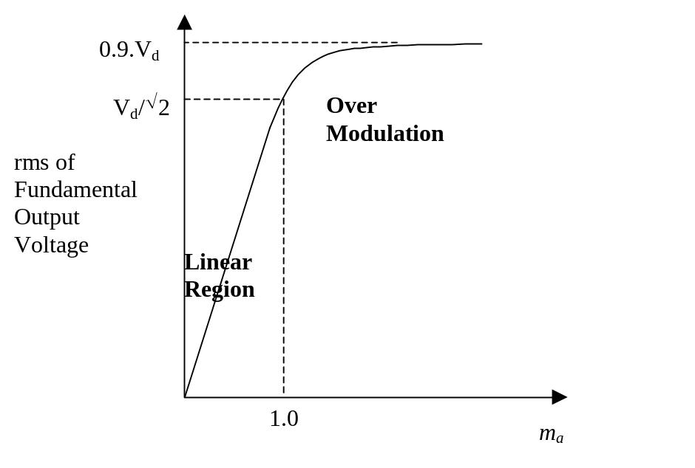

Bipolar Switching
In the preceding example TA+ and TB- are switched together while TB+ and TA- are switched together. This is perhaps the simplest modulation scheme as is known as bipolar switching. Other modulation schemes are possible which have advantages in terms of reduced harmonics and / or increased modulation range. For this reason simple bipolar pwm is rarely used in practise and students who come across inverters later in their careers are encouraged to study alternative pwm techniques. Common ones are: Unipolar switching, Sine+3rd harmonic pwm, Space Vector modulation. We will not be covering these on this course.

